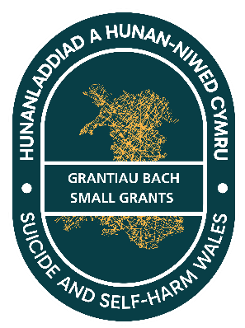
Suicide and Self harm Prevention Small Grants 2026/27
Supporting information

Grant application process
The applicant will be required to complete the SSHP Small Grants Application form and submit this by the closing date specified on the form. All the applications will be reviewed by a panel comprised of members of the SSHP team, an independent party and a person with lived experience.
Once the applications have been reviewed, the applicants will receive a letter stating one of four possible outcomes:
Outcome | Explanation
Decline | The application does not meet the criteria set out in the invitation letter and application form, and cannot be supported
Defer | The application meets the criteria, but either requires further development as a proposal, or is not deliverable within the stated timeframe (by March 31st, 2027). A revised application could be made in the next financial cycle
Accept with conditions | The application meets the criteria, the proposed activity is considered deliverable in the timeframe and will be supported with some agreed changes to project design and/or revisions to costings. E.g.: costs that relate specifically to staff time in established organisations have been revised
Accept | The application meets the criteria, the proposed activity is considered deliverable in the timeframe, and will be supported in full

If you are successful in your application, you will be allocated a member of the SSHP Team to provide support for the duration of your project.
All applicants and their staff and colleagues are encouraged to complete the SSHP Suicide Awareness e-module (https://www.sshp.wales/en/sshp-suicide-awareness-e-module/) and read the language statement (https://www.sshp.wales/en/knowledge-base/use-of-language/)
You can find the timeline for the process from application to award within the annex attached to the application form.
What will not be funded through the grant?
The grant funding cannot be used to initiate a new service or subsidise an existing service. This is because the funding is time limited, and the sustainability of such services could not be supported.
The grant funding cannot be used to repeat the same project or activity previously funded by this grant. Previous grant recipients may apply for funding for a new project or activity, but must demonstrate how it is different or adds value. If you are unsure, please contact the team for advice before making an application.
The grant funding cannot be used to fund staff training.
Materials and branding
If you are awarded a grant, any materials or property developed as part of your project must include the SSHP grants logo and be approved by the regional lead for your area, who may consult national colleagues as needed. This is due to the sensitive nature of suicide and self-harm and the need to ensure that all messaging is safe, evidence-informed, and consistent with national guidance.
Application Form
Do I need to meet all six objectives listed at the bottom of the form, or is it ok to meet one or some of them?
You do not need to meet all 6 of the objectives. Often, projects or interventions can address more than one, but your work may also be specifically focussed on one area. What we need to be able to see in your application is assurance that you understand the strategic context in which suicide and self-harm management and prevention in delivered in Wales, and for you to demonstrate how the outcomes of the work that you’re describing is going to contribute to the achievement of the strategic objective(s)

What if my project is piloting something new and the specific activity doesn’t have a clear evidence base yet?
Sometimes when you’re developing a new approach to a problem or issue there may not be a developed evidence base. There may be evidence around general approaches used in other areas, for example effectiveness of peer support groups, skills-based training approaches that you could draw on. For all applications, good practice would be to build an evaluation process into the work that you are doing, so that you can demonstrate the effectiveness of the work and identify any changes you might make to improve next time. This can help to contribute to the evidence base going forward.

Will I be able to ask questions about completing the application form?
The SSHP Team will be running a series of 10-minute drop-in sessions to answer any questions you may have about the application form. To book in to a session, please email sshp.cymru@wales.nhs.uk and a member of the team will let you know the dates and times the sessions are being held.

