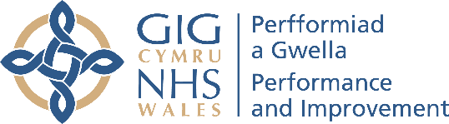 | Llawr 1af / 1st Floor  Tŷ Afon / River House  Llys Ynys Bridge / Ynys Bridge Court  Gwaelod-y-Garth / Gwaelod-y-Garth  CAERDYDD / CARDIFF  CF15 9SS / CF15 9SS  Email * Ebost: sshp.cymru@wales.nhs.uk

29th June 2026

To members of regional and local partnerships for suicide prevention and self-harm

Invitation to submit applications for small grant funding (up to £4,000) to support local activity focused on suicide prevention and self-harm

NHS Wales Performance and Improvement Suicide Prevention and Self-Harm Programme (SSHP) is making small grants available to support local activity focused on suicide prevention and self-harm .

This funding is available to support existing or developing projects, interventions, or programmes; or the initiation of new activities that have additional sources of funding or are supported by existing organisational capability.

Any agency can submit a proposal for a small grant from any sector.

The funding will be available during 2026/27 (up to 31st March 2027) and will not be recurring.

Examples of how funding could be used include i) co-design and production of resources or information and promotional materials to support local referral pathways, service navigation, or signposting; ii) co-production of new or bespoke training offers for particular groups or settings; iii) local events to support existing networks around a particular challenge or problem, or to set-up a new support network that can be sustained through existing resources after the grant; iv) activities that improve our understanding, and capture the voices, of those who are disproportionately affected by suicide and self-harm.

Activities that will not be supported are corporate staff training, the development of new services, or ongoing service delivery.

For 2026/27 we would encourage applications that:

- Support people or processes to improve our responses to self-harm
- Can update and refine sections of the online Help is at Hand Cymru resource
- Supports the adoption or implementation of the Integrated Quality Statement for Self-Harm
All activities must clearly align with the national strategic objectives set out in the new 10-year strategy, Understanding: a suicide prevention and self-harm strategy for Wales, and have sufficient evaluation and monitoring built in to be able to report on clear benefits and outcomes from the work.

A multi-agency/professional panel, including those with living experience, will appraise applications, and this panel will be open to innovative and creative proposals, and submissions that are prepared by a number of groups or agencies working together.

The total fund for the small grant programme will be determined by other costs being incurred by the national programme and its commitments to the three-year Strategic Delivery Plan 2025-2028

Attached to this letter, please find an application form with a submission deadline of 14th August 2026.

For help with preparing an application, please see the supporting information document and for further advice, please contact your regional lead:

North Wales: deborah.job@wales.nhs.uk
Southeast Wales: ceri.fowler2@wales.nhs.uk
Mid and West Wales: laura.tranter@wales.nhs.uk

Yours sincerely,
Claire Cotter

Claire Cotter
National Programme Lead for suicide prevention and self-harm
NHS Wales Performance and Improvement

Cc: Ciara Rogers, National Director, Mental Health, Learning Disabilities, and Neurodiversity, NHS Wales Performance and Improvement

Rydym yn croesawu gohebiath yn Gymraeg. Byddwn yn ymateg yn Gymraeg heb oedi.
We welcome correspondence in Welsh. We will respond in Welsh without delay

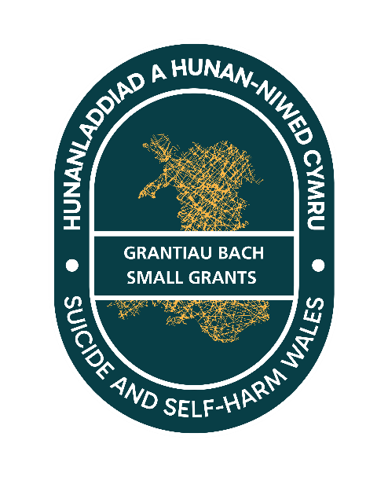
Application Form
Small grant for suicide prevention and self-harm 2026-27

Region(s) | North | Southeast | Mid-west | All-Wales
Link Regional Lead
Date of application

Organisation leading project delivery
Name of organisation submitting the application (this could be on behalf of a group of organisations)
Contact details of lead officer for communications regarding this application
List of organisations in the collaboration supporting and contributing to the delivery of this proposal
Organisation: |  | Email of lead contact:
Funding
Please give details of other Welsh Government or other grant sources of funding applied for/being held in relation to this work
TOTAL VALUE OF FUNDING being requested from SSHP small grants fund
Name of organisation that will hold and manage the budget for the project
Brief description of the work and the outcomes
What you will be doing, with whom, and the outcomes that will be delivered
Products or outputs that will be delivered
Approach for project delivery and evaluation
Please describe the outline project plan and key milestones
Timeframe for key milestones
Objective | Milestone |  | Date
Please describe how the project will be evaluated
Budget management
Please provide detailed costings for this proposal
Item  (e.g.: materials, digital design, venue/accommodation costs) |  |  |  | Cost (£)
TOTAL

Risks and Mitigations
Potential risks to delivery | Mitigating actions

Other requirements for compliance
Please describe how the proposed activity will demonstrate the following criteria (‘activity’ refers to the resources, service, project, programme, or intervention being proposed)
Requirement |  |  | Describe how the project meets this requirement
Strategic fit | Which Welsh Government Strategy objective(s) the activity will deliver on (see Annex)
Sustainability | Whether the activity meets an immediate need and can be completed within the costings/grant, and/or whether the work needs to continue longer-term, and the resources available to sustain the activity after the grant has been used
Transferability or upscaling | how the activity or outputs could benefit other areas, or other organisations, if repeated
Engagement | how people with living experience, service users, or citizens will participate in the design and/or delivery of the activity
Health inequalities and health needs | how the activity addresses inequalities and serves those disproportionately affected by suicide and self-harm
Collaboration | how the activity draws on the input of several agencies working in partnership
Asset based | how the activity builds on existing resource within a community and develops resilience for particular groups
Evidence base | how the activity design and delivery is informed by research or evidence of effectiveness (UK or beyond)
Welsh Language | how the work/product will be sensitive to the needs of the Welsh language and culture, and be available in Welsh and English
Willingness to collaborate with other bidders
During the appraisal of the applications, the panel may identify projects that would be enhanced and strengthened through collaboration between applying organisations.

Would you be open to collaborating with other organisations on this basis?
YES | NO | Signed:

Once completed submit an electronic version of this form to sshp.cymru@wales.nhs.uk by 5pm 14th August 2026
ANNEX

Objectives from “Understanding”, the National Suicide Prevention and Self-harm Strategy for Wales

Objective 1:  Listening and Learning | We will have streamlined processes for the collection, analysis, and interpretation of data, evidence and lived experience testimony; and robust infrastructure to ensure the intelligence gathered is used to develop policies, support, and services.
Objective 2:  Preventing | We will have a coordinated cross Government and multisectoral response to: • tackle the risk factors linked with self-harm and suicide • restrict access or exposure to harmful information online and in the media • limit access to methods that can cause harm • identify and manage locations of concern.
Objective 3: Empowering | Everyone will be empowered with the knowledge and awareness to recognise those in need, offer kind and compassionate support; and help them access services if needed.
Objective 4: Supporting | People who have suicidal ideation or self-harm, or those supporting them, will have access to timely and person- -centred support, intervention and treatment from all relevant services including primary care, mental health, urgent and emergency care, and third sector services
Objective 5:  Equipping | Services that support people with challenges which increase their risk of suicide and self-harm are equipped to identify people at risk and work with partner agencies to offer holistic, person-centred and compassionate support.
Objective 6: Responding | We will have timely responses to suicides and compassionate and person--centred support is available to all those affected.

Other Links for information

A More Equal Wales: The Socio-economic Duty | GOV.WALES 2021
Wellbeing of Future Generations (Wales) Act 2015
Social Services and Wellbeing (Wales) Act 2014
Mental Health (Wales) Measure 2010
Welsh language standards (welshlanguagecommissioner.wales)
Timeline for grants awarding

