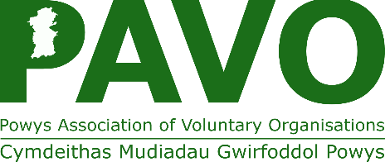
Helping Organisations
Improving Lives




Unit 30 Ddole Road Industrial Estate, Llandrindod Wells, Powys. LD1 6DF
info@pavo.org.uk Tel: 01597 822191

COMPLAINTS FORM
Please read PAVO Privacy Statement which is available here, which explains how we will process your personal data in connection with dealing with this complaint.
Name |  |  | Organisation
Address |  |  | Tel:
Address |  |  | Email:
Preferred method of contact |  | Post |  | Email |  | Telephone
Please give a brief summary of your complaint. Please include locations, dates, witnesses and any other information that you feel may be of benefit:
Have you already had contact with PAVO about this matter? If so, with whom and how was the contact made?
What would you like us to do about this matter?
If a complaint is made against an individual it may be impractical to fully investigate the complaint without that person being aware of your identity and the nature of your complaint. If for any reason you do not wish your identity to be revealed to the person concerned, please indicate this by ticking the box and set out your reasons below. We will endeavour to comply with your wishes wherever practicable.
I wish to remain anonymous because
Please sign and date and return to the address above marked for the attention of the Senior Officer Internal Services.

Signed
Date

